# ENTRY LEVEL



# ENTRY PATHWAYS

# Mathematics

## January 2014

## Contents

**INTRODUCTION**

**ENTRY LEVEL CERTIFICATE**

***The* *future of Entry Level***

***Performance Points***

***Important Dates 2014***

***CPD***

***Submitting Samples***

**ENTRY PATHWAYS MATHEMATICS**

***Performance Points***

***Provisional Entry Dates***

***CPD***

***Resources***

## 

## Introduction

Welcome to the Entry Level/Entry Pathways Mathematics e-Bulletin.  If you know someone else who would like to receive this e-bulletin, please forward them this email and ask them to visit our [website](http://www.wjec.co.uk/mathematicsentrypathways#form) and click the 'Subscribe' box

|  |  |
| --- | --- |
| Contacts |  |
| Betsan Jones  Subject Officer  029 2026 5318  [betsan.jones@wjec.co.uk](mailto:helen.francis@wjec.co.uk) | Rhian Williams  Subject Support officer  029 2026 5199  [rhian.williams@wjec.co.uk](mailto:matthew.roberts@wjec.co.uk) |

<http://www.wjec.co.uk/mathematicsentrylevel>

http://www.wjec.co.uk/mathematicsentrypathways

**ENTRY LEVEL CERTIFICATE**

***The future of Entry Level***

This qualification will be available until further notice.

We are hoping to update and revise the Entry Level Mathematics qualification in the near future and we would like to hear your views on what changes you would like to see.

Please complete the following questionnaire and return it to [betsan.Jones@wjec.co.uk](mailto:Betsan.Jones@wjec.co.uk)

***Performance Points***

The Department for Education has recently revised the criteria which must be met for qualifications to attract performance points. Unfortunately, for the 2014 performance measure, all Entry Level qualifications and those at Level 1 which have no direct links to a Level 2 qualification will not be included in these tables after 2013.

**This applies only to centres in England.**

***Important Dates 2014***

*Examination date -* 18March 2014 (a.m.)

*Coursework submission* - 2 May 2014

Copies of the Assessment Pack (coursework tasks) can be found on the [secure website](https://www.wjecservices.co.uk/Default.asp) (PDF Resources Download>Controlled Assessment Materials).

#### ***CPD***

#### There is no face-to-face CPD planned for Entry Level Mathematics. Online CPD provision will be available in the autumn term. Centres are reminded that previous CPD material and additional resources are available for teachers to access on the [Secure Website](https://www.wjecservices.co.uk/Default.asp)

***Submitting samples***

The number of samples required for submission from September 2013 has changed. Details are explained on the [sample sheet](http://www.wjec.co.uk/uploads/publications/18812.docx) and within the specification.

|  |  |
| --- | --- |
| *Total number of candidates* | *Work to be submitted*  *(Numbers relate to rank order)* |
| 1 – 10 | All |
| 11 - 19 | 1st and every second (1, 3, 5, 7 etc.) **plus** the lowest scoring folder and additional folders as necessary (reflecting the spread of marks) to make a total sample of 10 |
| 20 - 45 | 1st and every fifth (1, 6, 11, 16 etc.) **plus** the lowest scoring folder and additional folders as necessary (reflecting the spread of marks) to make a total sample of 10 |
| 46 - 99 | 1st and every eleventh (1, 12, 23, 34 etc.) **plus** the lowest scoring folder and additional folders as necessary (reflecting the spread of marks) to make a total sample of 10 |
| 100 - 199 | 1st and every fourteenth (1, 15, 29, 43 etc.) **plus** the lowest scoring folder and additional folders as necessary (reflecting the spread of marks) to make a total sample of 15 |
| 200 – 299 | 1st and every fifteenth (1, 16, 31, 46 etc.) **plus** the lowest scoring  folder and additional folders as necessary (reflecting the spread of  marks) to make a total sample of 25 |
| Over 300 | 1st and every twentieth (1, 21, 41, 61 etc.) **plus** the lowest  scoring folder and additional folders as necessary (reflecting  the spread of marks) to make a total sample of 25 |

**ENTRY PATHWAYS**

***Performance Points***

The Department for Education has recently revised the criteria which must be met for qualifications to attract performance points. Unfortunately, for the 2014 performance measure, all Entry Level qualifications and those at Level 1 which have no direct links to a Level 2 qualification will not be included in these tables after 2013.

**This applies only to centres in England.**

***Provisional Entry Dates (more information will follow)***

May series - **21 February 2014** centres can then amend entries up to 30 April 2014

Work to be submitted by 2 May 2014

Any entries received after the above dates will need to be entered in the next examination session.

***CPD***

There is no face-to-face CPD planned for Entry Pathways Mathematics. Online CPD provision will be available soon. The materials from previous Entry Pathways Mathematics CPDs are available to download via our [secure website](http://www.wjecservices.co.uk/) (Resources PDF download>CPD (INSET) Materials).

***Resources***

The [Units and Guidance booklet](http://www.wjec.co.uk/uploads/publications/15273.pdf) has now been updated. Further clarification for some of the Assessment criteria is now included as well a summary grid for each unit.

The revised booklet has been uploaded to the website.

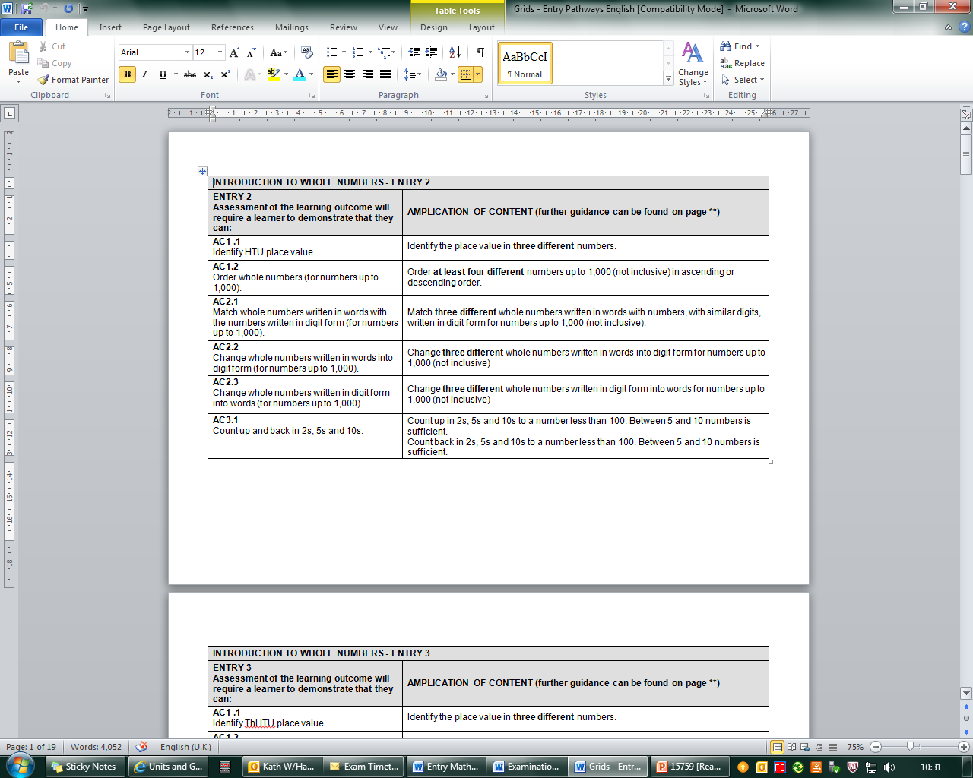

*Example: 6370/E2 Introduction to whole numbers summary grid*

Tracking grids were used by the external moderators and it was decided to make these available to centres. These can be useful when tracking candidates’ progress as evidence is collated and when internally moderating work. These are NOT meant to replace the Assessment Records and there is no to submit them to WJEC. The tracking grids have been uploaded to the website (an example is below).



*Example: 6370/E2 Introduction to whole numbers tracking grid*

If you have any questions, please do not hesitate to get in touch.

Kind regards,

Betsan