# ENTRY LEVEL



# Mathematics

## April 2014

## Contents

**INTRODUCTION**

**MODERATION SAMPLES**

**SUBMISSION OF MARKS**

## 

## Introduction

Welcome to the Entry Level Mathematics e-Bulletin.  If you know someone else who would like to receive this e-bulletin, please forward them this email and ask them to visit our [website](http://www.wjec.co.uk/mathematicsentrypathways#form) and click the 'Subscribe' box

|  |  |
| --- | --- |
| Contacts |  |
| Betsan Jones  Subject Officer  029 2026 5318  [betsan.jones@wjec.co.uk](mailto:helen.francis@wjec.co.uk) | Rhian Williams  Subject Support officer  029 2026 5199  [rhian.williams@wjec.co.uk](mailto:matthew.roberts@wjec.co.uk) |

<http://www.wjec.co.uk/mathematicsentrylevel>

http://www.wjec.co.uk/mathematicsentrypathways

**MODERATION SAMPLES**

Coursework submission deadline: **4 May 2014.**

Please note that the number of samples required for **ENTRY LEVEL** submissions from September 2013 has changed.

Details are explained below and can also be found within the specification.

|  |  |
| --- | --- |
| *Total number of candidates* | *Work to be submitted*  *(Numbers relate to rank order)* |
| 1 – 10 | All |
| 11 - 19 | 1st and every second (1, 3, 5, 7 etc.) **plus** the lowest scoring folder and additional folders as necessary (reflecting the spread of marks) to make a total sample of 10 |
| 20 - 45 | 1st and every fifth (1, 6, 11, 16 etc.) **plus** the lowest scoring  folder and additional folders as necessary (reflecting the spread of  marks) to make a total sample of 10 |
| 46 - 99 | 1st and every eleventh (1, 12, 23, 34 etc.) **plus** the lowest scoring folder and additional folders as necessary (reflecting the spread of marks) to make a total sample of 10 |
| 100 - 199 | 1st and every fourteenth (1, 15, 29, 43 etc.) **plus** the lowest scoring folder and additional folders as necessary (reflecting the spread of marks) to make a total sample of 15 |
| 200 – 299 | 1st and every fifteenth (1, 16, 31, 46 etc.) **plus** the lowest scoring  folder and additional folders as necessary (reflecting the spread of  marks) to make a total sample of 25 |
| Over 300 | 1st and every twentieth (1, 21, 41, 61 etc.) **plus** the lowest  scoring folder and additional folders as necessary (reflecting  the spread of marks) to make a total sample of 25 |

**SUBMISSION OF MARKS**

A new online system for the submission of marks and the identification of a sample in centre-assessed units will be applied to the Entry Level Mathematics qualification from the May 2014 series.

You will no longer be required to submit your C-forms which have been used in previous years. **You will still need to send the M1 sample mark sheet with your moderation sample**.

The new system involves the inputting of centre marks by subject teachers into a web-page which will be pre-populated with the relevant candidate entry details. This will then automatically identify the sample of candidates and will enable the sampling process and the upload of marks to be completed in a single electronic transaction.

All subject teachers who will be uploading marks will therefore require

(i) a secure website account,

(ii) access to the “Enter Coursework Marks” facility, and

(iii) access to the specific web page(s) for their subjects.

Website primary account holders (i.e. exams officers) can now create the necessary accounts and allocate the required access via the Account Admin page, in readiness for the upload of marks.

It is only the total mark out of 237 that will need inputting onto the system. Therefore, you will still need to complete and submit the M1 form and individual log sheets.

If you have any questions, please do not hesitate to get in touch.

# LEFEL MYNEDIAD



# Mathemateg

## Ebrill 2014

## Cynnwys

**CYFLWYNIAD**

**SAMPLAU SAFONI**

**CYFLWYNO MARCIAU**

## Cyflwyniad

Croeso i e-Bwletin Lefel Mynediad Mathemateg. Os ydych yn nabod rhywun hoffai derbyn yr e-Bwletin yma, danfonwch nhw i'r [wefan](http://www.cbac.co.uk/index.php?subject=90&level=203/#form) a llenwi'r ffurflen ar ddiwedd y dudalen

|  |  |
| --- | --- |
| Cysylltwch |  |
| Betsan Jones  Swyddog Pwnc  029 2026 5318  [betsan.jones@cbac.co.uk](mailto:helen.francis@wjec.co.uk) | Rhian Williams  Swyddog Cefnogaeth Pwnc  029 2026 5199  [rhian.williams@cbac.co.uk](https://hwb/domain/mathsci/Shared%20Documents/Sciences/Physics/GCE/Correspondence/email%20bulletins/rhian.williams@cbac.co.uk) |

http://www.cbac.co.uk/mathemateg

***SAMPLAU SAFONI***

Dyddiad cyflwyno gwaith cwrs: **4 Mai 2014**

Mae’r nifer o samplau gofynnol ar gyfer **LEFEL MYNEDIAD** wedi newid o Medi 2013.

Mae manylion a eglurhad pellach ar gael ar y ffurflen sampl a tu fewn y manyleb.

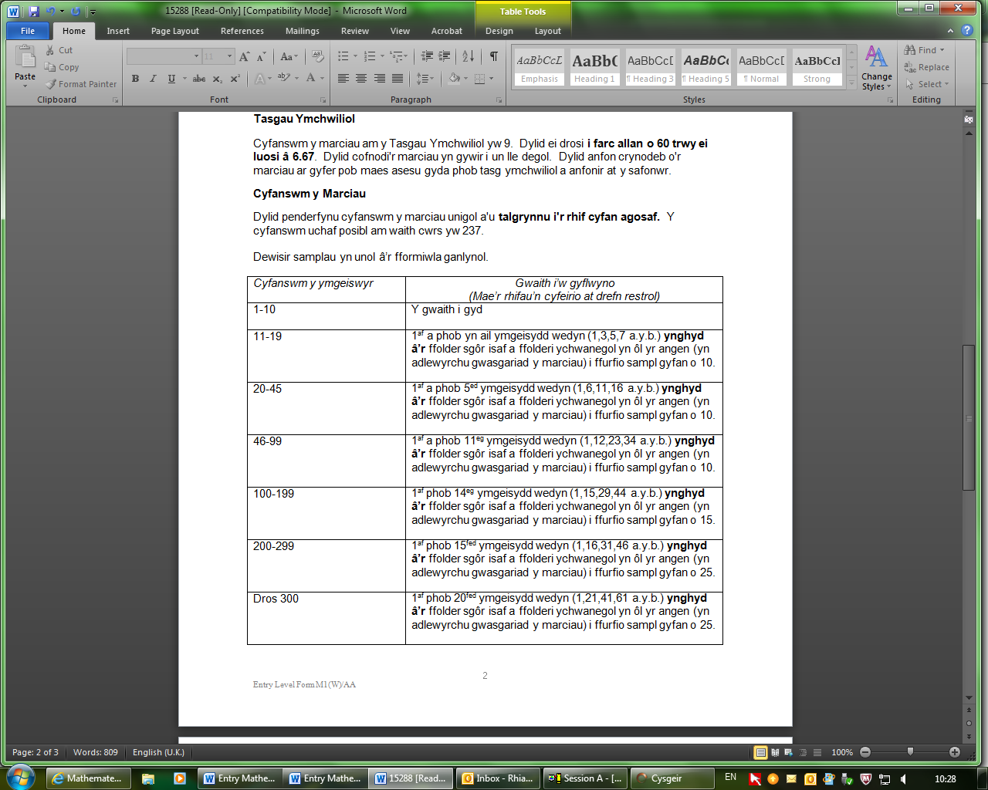

CYFLWYNO MARCIAU

Bydd system ar-lein newydd i gyflwyno marciau ac adnabod y sampl mewn unedau a asesir yn y ganolfan yn cael ei chymhwyso i’r cymhwyster Lefel Mynediad Mathemateg o gyfres mis Mai 2014.

O hyn ymlaen, ni fydd angen i chi gyflwyno’r ffurflenni C a gafodd eu defnyddio mewn blynyddoedd blaenorol. **Bydd angen i chi anfon y daflen farciau sampl M1 gyda’ch sampl safoni o hyd.**

Mae’r system newydd yn golygu mewnbynnu marciau’r ganolfan gan yr athrawon pwnc i dudalen we sy’n cynnwys manylion cofrestru’r ymgeiswyr perthnasol. Yna bydd hyn yn adnabod y sampl o ymgeiswyr yn awtomatig ac yn galluogi’r broses samplu a llwytho i fyny’r marciau i’w cyflawni mewn un trafodiad electronig.

Felly bydd angen i bob athro pwnc sy’n llwytho marciau i fyny gael y canlynol:

1. cyfrif gwefan ddiogel,
2. mynediad i’r cyfleuster “Mewnbynnu Marciau Gwaith Cwrs”

a

1. mynediad i’r dudalen/tudalennau gwe penodol ar gyfer eu pynciau

Yn awr, gall deiliaid cyfrifon cynradd (h.y. swyddogion arholiadau) greu’r cyfrifon angenrheidiol a dyrannu’r mynediad gofynnol trwy’r dudalen Gweinyddu Cyfrif, yn barod i lwytho’r marciau.

Dim ond cyfanswm y marc allan o 237 y bydd angen ei fewnbynnu i’r system. Felly, bydd angen i chi lenwi a chyflwyno’r ffurflen M1 a thaflenni log unigol o hyd.

Os oes gennych unrhyw gwestiynau pellach, peidiwch ag oedi cyn cysylltu â ni.